Practical – 10
Name: UMANG VISHWANATH GEDAM
Class: SY-A
Roll No: A-32
Aim:
To understand and implement version control using Git and GitHub.

Theory:
Version Control is a system that helps track changes in files over time. It allows multiple users to work on a project and keeps a history of changes.
Git is a distributed version control system used to track changes locally.
GitHub is an online platform used to store and manage Git repositories remotely.
Using Git and GitHub, we can:
- Track file changes
- Collaborate with others
- Maintain version history
- Restore previous versions

⚙️ Step-by-Step Procedure

Step 1: Installation Verification
Command used:
git --version
Git installation was verified successfully.

Step 2: Configure Username & Email
Commands:
git config --global user.name " umanggedam5777"
git config --global user.email " umanggedam5777 @gmail.com"

Step 3: Create Local Repository
Commands:
mkdir myproject
cd myproject
git init
A new Git repository was initialized.

Step 4: Create File
Command:
echo Hello Git > file1.txt
A new file was created in the repository.

Step 5: Add File to Staging Area
Command:
git add file1.txt

Step 6: Commit Changes
Command:
git commit -m "Initial commit"
Changes were successfully committed.
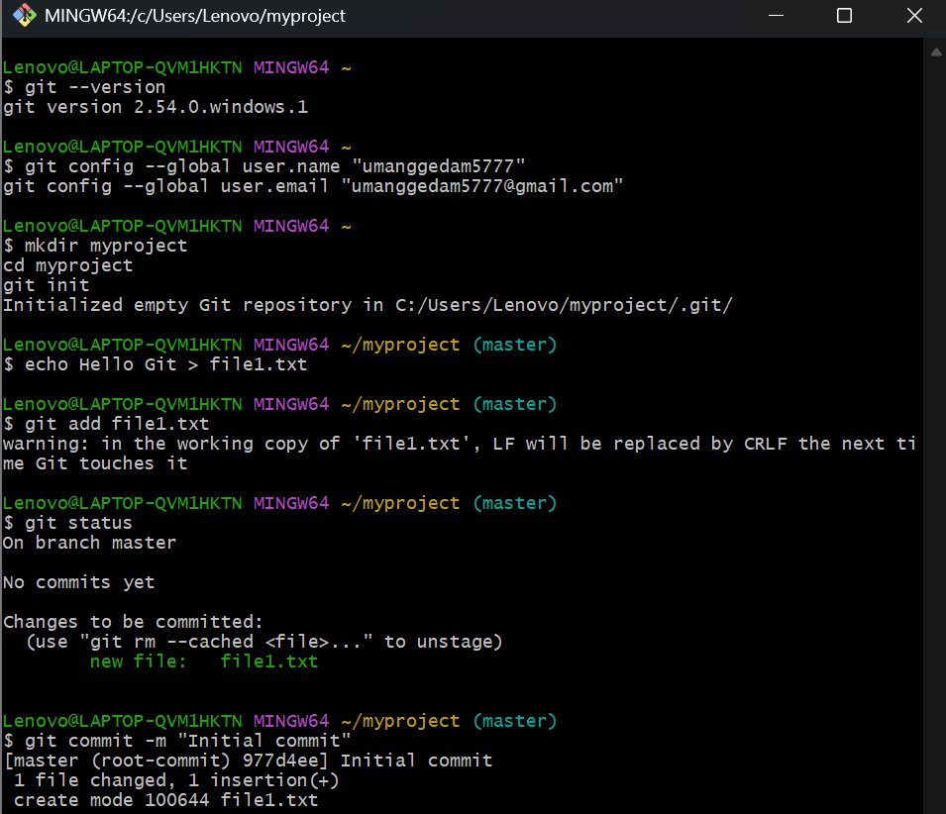
Step 7: Create GitHub Repository
A new repository named PDS_PRACTICALS was created on
👉 GitHub
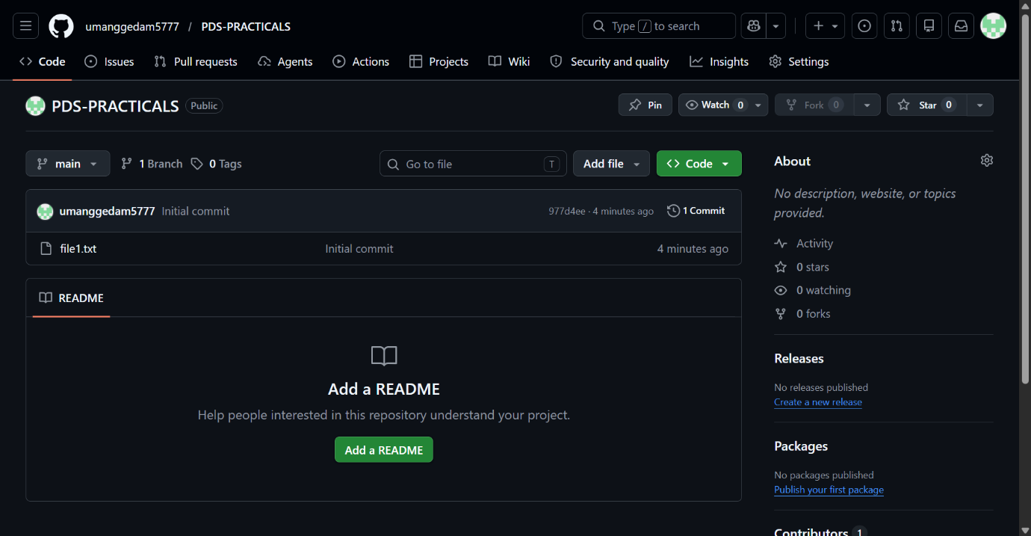

Step 8: Link Local Repository to GitHub
Command:
git remote add origin https://github.com/ umanggedam5777/PDS_PRACTICALS.git

Step 9: Push Files to GitHub
Commands:
git branch -M main
git push -u origin main
The files were successfully uploaded to GitHub.
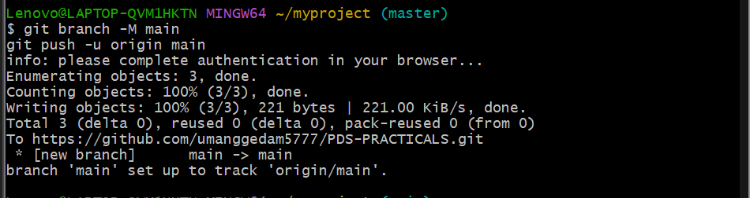

Step 10: Verify Files on GitHub
The file file1.txt is visible in the GitHub repository.
📸 Screenshot 6: Files on GitHub

Step 11: Display Commit Logs
Command:
git log
📸 Screenshot 7: Commit history


📘 Questions & Answers

1. What is the difference between Git and GitHub?
- Git: A version control system used to track changes in files locally.
- GitHub: A cloud-based platform used to store and manage Git repositories online.

2. Difference between git add and git commit
- git add: Adds changes to the staging area.
- git commit: Saves changes permanently in the repository.

3. What is the staging area in Git?
The staging area is a temporary space where changes are prepared before committing them to the repository.

4. What happens if you modify a file after committing it?
Git detects it as a modified file. You must again use:
git add
git commit
to save the new changes.

5. Difference between git push and git pull
- git push: Uploads local changes to GitHub repository.
- git pull: Downloads latest changes from GitHub to local system.

6. What is Version Control? Differentiate between Centralized and Distributed VCS
Version Control is a system that tracks changes in files over time.
Centralized VCS:
- Single central server
- Example: SVN
- Users depend on server
Distributed VCS:
- Each user has full copy of repository
- Example: Git
- Works even without internet

Final Conclusion
This practical successfully demonstrated the use of Git and GitHub for version control. All steps including repository creation, staging, committing, and pushing to GitHub were performed correctly. The experiment helped in understanding how version control systems manage project history and enable collaboration.

